
THE LIGHTHOUSE

Newsletter for April 2018

Many are asking, "Who can show us any good?" Let the light of your face shine upon us, O LORD.
Psalm 4:6

Message from Our Pastor

Dear Sisters and Brothers in Christ,

Alleluia! Christ is risen!
Christ is risen indeed. Alleluia!

I love hearing this proclamation of the good news. It warms my heart and gives me hope. It also brings back good memories, because it was the first proclamation of the good news I proclaimed on my journey in ministry! The story goes like this. It was on Good Friday of 2002. I felt the call to ministry and after a very long discussion with my Pastor that afternoon, I found myself on Easter morning in a white Alb shouting out to my home congregation those beautiful words!
Those words demonstrate the power Jesus has over death even after his sacrifice on the cross on Good Friday. In his resurrection we no longer need to live in fear of death. Christ’s resurrection proves that there is life after death. As Christians we believe that because in baptism we have been connected to Christ in his death, we will also be connected to him in his resurrection (Romans 6:3-5). We believe that what happened to Jesus is happening and will happen to us. The message of the cross and empty tomb has always been the most important message anyone could ever hear. It is especially so in these times of doubt, of hopelessness, of unprecedented worry and angst, that we may feel and hear so much of today. That is the reason the message of Jesus’ resurrection needs to be heard! He is the light that shines through the darkness!!
God’s richest blessings to you as you celebrate the defeat of death and the guarantee of salvation in the resurrection of our Lord Jesus Christ!

Alleluia! Christ is risen!
Christ is risen indeed. Alleluia!

Yours in Christ,
Pastor David

Newsletter

The April Newsletter was adopted by Marialana Nygard


In loving memory of
Jack Nygard

Noisy Offering

The April Noisy Offering will go to Always Being Made New Campaign

Women’s Group

The Zion Women’s Group will not meet in April.

Adult Bible Study

Bible Study at Trinity will be Tuesdays at 6 pm.

Easter Services

Maundy Thursday Service (March 29th) will be at Zion at 7 pm.

On Good Friday (March 30th) there will be a service at the United Methodist Church at noon.


At @6:30 am on Easter Sunday there will be a Sunrise Service at Trinity.


The 11 am Easter Service at Zion will be followed by an Easter egg hunt.

Confirmation

Confirmation will be on April 8th from 5 to 7 pm

Long-Term Care

Evergreen Living Center:
Barb Lehto
Judy Ryerse

Prayer List

(The prayer list is started new each year. If you would like someone added to the prayer list, please fill out a yellow card or call the church)

Mary Belonga, Dave & Lois Movalson, Barb Lehto, Bev Kammers, Eunice Therrian, Craig Therrian, Shirley Winberg, Richard Galor, Judy Ryerse, Cindy Hendricks, Carol Litzner, Holly Lester, Lalah Rippitt, Sandy Huskey, Jim & Jerri Rose, Bill & Sandy Tielbar, Walter & Jane Puccio, Carol & John Watson, Mike & Linda Wilkins, Larry Hopper, David Lloyd, Donna Harju, Tom Beaudoin, Terri Hill, Elizabeth Kaminsky, Merlin Doran (Merlin’s father), the families and friends of Raleigh Harrington, Devan Tielbar, Linda Burrows and Chet Sayles.

Congratulations! & Thank You!

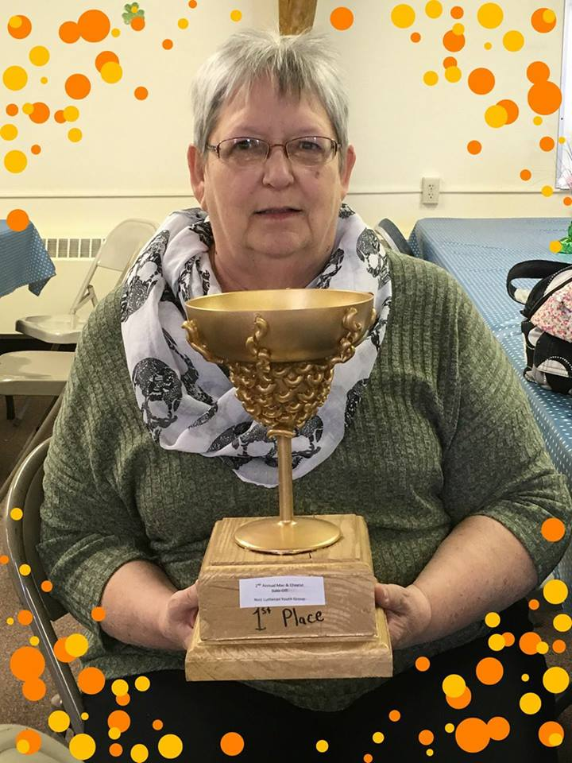
Congratulations to Pega Kennedy
for winning the Mac-n-cheese Bake-
Off for the 2nd year in a row!
Thank you to all the participants
(those who entered their creations
and those that taste-tested them all)!
The Youth Group is grateful for the
money raised toward their trip to
Houston.

Thank You!

Feeding America would like to thank Zion Evangelical Lutheran Church of St. Ignace for sponsoring the March Mobile Food Pantry!
Baptismal Anniversaries

Toni Johnston 2
Marion Hill 3
Kyle Elmblad 3
Wyatt Huhn 4
Chase DeKeyser 8
Logan DeKeyser 8
Danielle Ford 8
Nicole Elmblad 11
Bonnie Bergeron 11
Matthew Valetta 11
Adam Chambers 15
Tyler Chambers 15
Brian Harju 15
Devan Harju 15
Jody Harju 15
Luke Valletta 15
Judy Massey 17
Gracia St. Andrew 17
Marlene Olsen 19
Becky Paul 19
Cierra Barker 20
Savannah Barker 20
Noah Mathew Huhn 20
Micah Gaubault 21
Dan Spencer 21
Preston Spencer 21
Shannon Huhn 22
Tammy Shepard 23
Bailey Ryerse 24
Donovan Insley 25
Mike Lehto 26
Merlin Doran 28

April Birthdays

Emma Feleppa 1
Merlin Doran 2
Jim Rose 3
Skyler Music 6
Barb Lehto 7
Susan Fenlon 8
Morgan LaVake 8
Benjamin Lennington 14
John Kennedy 14
Andrew Sjogren 15
Jacob Sjogren 15
Helena Kissinger-St. Onge 17
Sharon Chalmers 17
Denise Maxson 18
John Chambers 20
Shannon Martin 20
Sybil Swadling 24
Jeni Therrian 24
Nicole Coveyou 25
Cooper Johnston 25
Sarah Doran 27
Devan Harju 27
Rebecca LaLonde 30

Wedding Anniversaries

Matt & Loni LaJoice April 13

Zion Funeral Committee February - May

Team Leader: Lorraine Graham (643-8419)
Co-leader: Betsy Turf (643-1512)

Servants for Zion

Ushers & Greeters

Apr 1 Merlin & Shannon Doran
Apr 8 Les & Debbie Therrian
Apr 15 LaJoice Family
Apr 22 Sam LaVake family
Apr 29 Hilda Ryerse & Martha Sjogren

Lectors

Apr 1 Lorraine Graham
Apr 8 Rita LaVake
Apr 15 Betsy Turf
Apr 22 Lynn Evans
Apr 29 Sandy Feleppa

Communion Assistants

Apr 1 Stevan Christiansen
Apr 8 Dena Barker
Apr 15 Mary Christiansen
Apr 22 Carol Elmblad

Acolytes

Apr 1 Josh Feleppa
Apr 8 Gunnar Olsen
Apr 15 Brendan Insley
Apr 22 Josh Feleppa

Altar: Lorraine Graham
Money Counters: Stevan & Mary Christiansen

We will be providing the Long Term Care Service on April 22nd. Please help out if you can.
The Usher duties are:
- Arrive 30 minutes before church
- Pass out bulletins and welcome guests
- Help with the offering and communion
- Record attendance

Trinity Worship Families

Apr 1 Rose Family
Apr 8 Movalson Family
Apr 15 Baron Family
Apr 22 Chalmers Family
Apr 29 Kennedy Family

Contact Information

Pastor David Tielbar may be reached at 906-984-2051 or at david.tielbar6@gmail.com. In an emergency, you can reach the Pastor’s cell phone at (563) 880-4512

Church telephone: 906-643-7870 - Answering machine
The secretary will usually be in the office on Tuesday and Thursday mornings from 9 – 12

The website is at http://zionstignace.com/home.html
- Find us on facebook at www.facebook.com/zionstignace

Email: ziontrinity950@gmail.com

Zion Evangelical Lutheran Church and Trinity Lutheran Church are congregations of the Northern Great Lakes Synod and the Evangelical Lutheran Church in America.

Trinity’s Sunday Service is at 9 a.m.
Zion’s Sunday Service is at 11 a.m.

Council Meetings

Trinity Council – April 17, 6 pm
Zion Council – April 19, 6 pm

Zion’s Council Members
President: Steve Christiansen 298-1051
Vice-President: Carol Elmblad 630-4380
Co-Treasurers: Dawn Akers 643-7552
Co-Treasurers: Lana Lennington 643-6576
Mary Christiansen 235-6123
Robert Marshall 643-8936
Secretary Dena Barker 430-1460
Emma Feleppa 430-8011
Tammy Shepard 906-984-2064

Trinity’s Council Members
President: Jerri Rose 292-5570
Vice-President Sharon Chalmers 292-5440
Secretary: Tracy Movalson 292-5581
Treasurer: Pega Kennedy 292-5633
Co-Treasurer: Jim Rose 292-5570
Financial Secretary: Tom Gustafson 292-5460
WELCA: Pega Kennedy 292-5633
John Kennedy 292-5633
Lois Movalson 292-5581

~~~~


A candle loses nothing
by lighting another candle.

Zion Lutheran Council Meeting
March 21, 2018

Council Members Present: Stevan & Mary Christiansen, Robert Marshall, Carol Elmblad, Dena Barker and Pastor David

Steve called the meeting to order at 6:06 pm.

Pastor David opened with prayer and devotion.

Pastor’s Report approved.

Secretary & Treasurer’s Reports discussed and approved.

$1100 raised from the Mac-n-cheese Cook-off.

Discussed “Building Vitality” program as a possibility concerning issues with attendances, finances, etc.

Discussed possibility of Saturday evening service in place of Sunday Service. Possibly put on Facebook page as a survey.

Council is concerned regarding church bills. Looking into avenues to remedy the situation.

Pancake breakfast was cancelled.

$2300 approved from endowment fund towards NOIZ Youth Trip. (Funds were short due to several pulling out of trip.) The
Endowment Committee met to discuss this and it was approved.

Paul Shepard and family will be doing our lawn care for the church. Thank you!

We have redone some of the lighting in the basement. Considering “Buy a Bulb Campaign” to raise money to purchase other needed bulbs. Purchasing LED bulbs will save the church money on electrical.

Next council meeting scheduled for April 19th at 6 pm.

Respectfully Submitted, Dena Barker

Trinity Lutheran Church

Council Meeting Minutes
January 28, 2018

Opened at 4:58 pm

Present: Pastor Dave, Jerri & Jim Rose, Pega & John Kennedy, Tracy Movalson, Tom Gustafson, Sharon Chalmers, Lois Movalson

Pastor led the meeting with a Prayer from Mark 1: 27 ‘authority’

Adoption of Agenda was motioned by Pega and Seconded by Sharon and approved.

The minutes from January 2017 meeting was approved.

Pastor’s report was accepted. Church’s benevolence for 2017 include; scholarships for Wartburg Theological Seminary and Northern Great Lakes synod. Donation to St Ignace HOPE to help local people in need. Tuesday bible study continues to be a joy.

President’s report was accepted. Highlights; a member built a new cabinet to our paraments and hand rail for the alter. Investment funds performing well.

WELCA report was accepted. Memorable events included; Easter Breakfast, Midsummer Pole Raising, and our Annual Community Dinner.

Endowment committee and Building committee are dissolved until next council meeting.

New Business:

Look at updating the constitution with things to add and review.

2018 budget:

Budget approved.

Statement of intent for benevolence pledge. Keep amount same as 2017.

Treasurer’s Report was read and approved.

Financial Secretary’s Report was read and approved.

Elections will take place at next council meeting

Meeting adjourned at 5:18PM

Respectfully Submitted by Tracy Movalson, Secretary

Trinity Lutheran Church

Council Meeting Minutes
March 20, 2018

Opened at 6:08pm

Present: Pastor Dave, Jerri & Jim Rose, Pega and John Kennedy, Tracy Movalson, Lois Movalson, Sharon Chalmers

Pastor led the meeting with Psalm 119, verse 15

Pastors Report: was read

Secretary’s Report was read and approved.

Treasurer’s Report was read and approved.

Financial Secretary’s Report was not available

Old Business:

Need to get phone numbers for our phone tree, so that we can call members if church cancels.

Foundation: get gutters and see if that improves the condition. Get money from endowment fund.

New Business:

Nordic Heritage Webinar for Tuesday, April 24 at 11AM at church. Pastor Dave will help set up. This is an organization that is considering us for a restoration grant.

Easter sunrise service will be at 6:30am under the pavilion. Need to find a fire pit.

Pastor passed out the readings for Palm Sunday. We will read The Passion.

Correspondence:

Pega shared the Shute Oil balance.
Superior Alliance for Independent Living requesting to come to a meeting and give presentation.

Synod looking for seminary support. Synod looking for support for ‘Answer the Call’ collection.

Meeting adjourned at 7:11PM
Respectfully Submitted by Tracy Movalson, Secretary

~~~~

Easter Lilies given for 2018

The Akers, Doran & Schlehuber families | In memory of Ramona Beeck Akers
Marlene Olsen | In memory of loved ones
Jackie Dell | In memory of Donald Dell
Lynn Evans | In memory of James Morand
Donna B. Harju | In memory of Charles Harju
The Idalski family | In memory of loved ones
The Feleppa family | In honor of loved ones
Hilda & Jim Ryerse | In memory of our parents
Richard Galor | In memory of my wife, Peggy
Lois Movalson | In memory of Ella Atwell  In memory of Ruby Movalson
Betsy & Alan Turf | In memory of our parents  In honor of our children

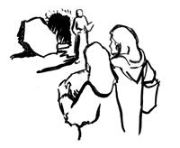

He is risen!
Share the good news!

